



Implementation of End-to-End String Operations
LAB MANUAL

Disclaimer: The content is curated from online/offline resources and used for educational purpose only
Implementation of End-to-End String Operations

Objective:
- Learn how to create and access strings, including indexing, slicing, and iterating over string characters.
- Combine strings using concatenation and repetition techniques.
- Convert strings to upper case, lower case, title case, and swap case.
- Search for substrings using methods like find(), index(), startswith(), and endswith().
- Replace substrings within a string using the replace() method.
- Format strings using various methods, including the format() function, f-strings, and % formatting.
- Trim white spaces from the beginning or end of strings and pad strings to a certain length.
- Split a string into a list based on a delimiter and join a list of strings into a single string.
- Count occurrences of specific characters or substrings using the count() method.
- Check whether a string is numeric, alphabetic, alphanumeric, or contains only whitespace using string methods like isalpha(), isdigit(), and isspace().
Problem Statement:
In this problem, you will explore how to perform various string operations using Python. The objective is to understand and apply different methods and techniques for manipulating strings, handling string data, and performing common operations such as concatenation, slicing, formatting, searching, and modifying strings.

Equipment Required:
- Install VS Code - https://code.visualstudio.com/download
- Download Python Installer File - https://www.python.org/downloads/
Prerequisites:
- Basic Computer Skills - Anyone starting to learn computer programming needs basic computer skills.
- Basics of control statements

Procedure:

Task 1: Implementation of Creating and Accessing Strings
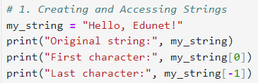
Output:
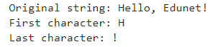
Task 2: Implementation of String Concatenation and Repetition
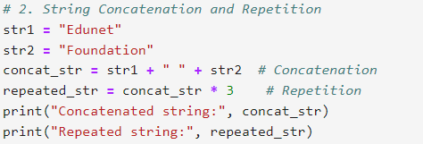
Output:
Task 3: Implementation of String Case Manipulation
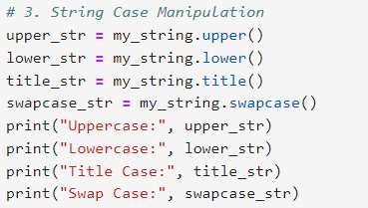str = my_string_
Output: su
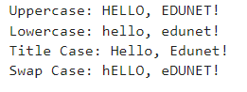
Task 4: Implementation of Searching in Strings
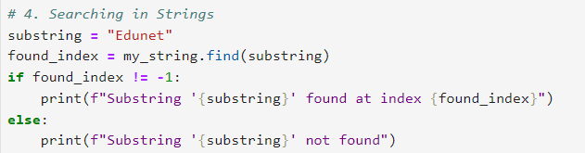
Output:
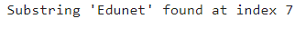
Task 5: Implementation of Replacing Substrings
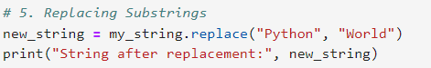
Output:
Task 6: Implementation of String Formatting
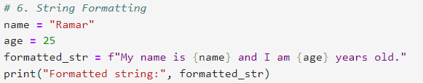
Output:
Task 7: Implementation of Trimming and Padding String s

Output:
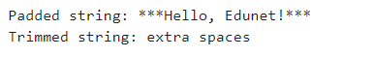
Task 8: Implementation of Splitting and Joining Strings
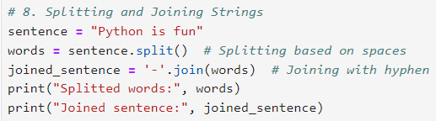
Output:
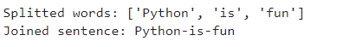
Task 9: Implementation of Counting Characters
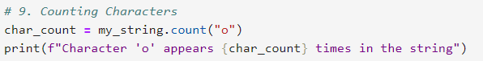
Output:
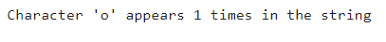

Task 10: Implementation of Checking String Properties
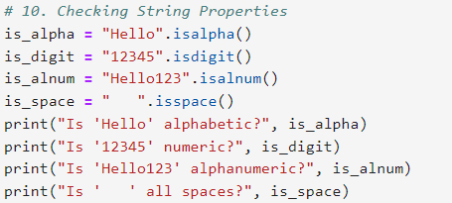
Output-
